Case Study on Impact of the Covid-19 Pandemic on Latin America
By Ángeles Sánchez Díez , Autonomous University of Madrid and José Manuel García de la Cruz , Autonomous University of Madrid
Summary (from p.1)
The COVID-19 pandemic has resulted in an 8.1% drop in GDP in Latin America, overcoming the impact of the crisis in the European Union and other emerging economies. However, the Latin American economies already showed significant weaknesses before the start of the health emergency. In other words, the pandemic has exacerbated the productive and social problems of Latin America , such as the region's perverse commercial specialization, the weakness of the productive fabric and the labor market, and social problems.
Impact on Poverty and Income Distribution (from p. 6)
In the years before the pandemic, Latin America had managed to reduce these rates [of inequality and poverty] . Poverty had gone from affecting 45.2% of the population in 2001 to 30.3% in 2019. Now, with covid-19, the number of poor will increase by 28.7 million people, reaching the figure of 214.4 million poor in the region. In turn, extreme poverty will affect 15.9 million more, totaling 83.4 million people.
After a few years in which the Gini index had fallen from 0.53 to 0.46 between 2001 and 2019, the pandemic has caused huge social costs that are very unevenly distributed. This increase in inequality has rekindled social protests in the region, generalizing those already manifested during the second half of 2019 in Chile, Ecuador and Colombia.
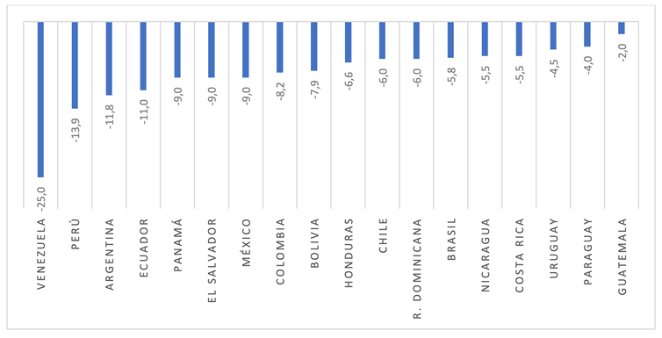GDP variation for Latin America in 2020 (in%) Source: IMF (growth forecasts made in October 2020. The IMF does not make forecasts for Cuba)

Although we speak of Latin America as a whole, the differences between countries are very high. Peru, Argentina, Ecuador, Panama, El Salvador, Mexico and Colombia have been the most affected countries. On the contrary, Paraguay, Uruguay and, especially, Guatemala have been affected to a similar degree to that of other developing and emerging economies. Venezuela is the country that has registered a greater drop in its production, as in previous years, although this cannot be attributed only to the impact of the virus.

The impact on economic sectors
The pandemic will have caused the closure of 2.7 million Latin American companies, that is, 19% of all companies. But social distancing measures and mobility limitations have unevenly affected economic activities.
Tourism, culture, commerce, transport and fashion have been the most affected sectors. These represent 24.6% of GDP and 34.2% of employment. In contrast, the activities that have been least affected have been agriculture, livestock and fishing, food production, medical products and telecommunications. These activities account for 14.1% of GDP and 18.2% of employment.
92% of technology-intensive production has suffered a strong impact from the crisis. This is a clear alarm signal for the medium term: the old specter of being on the sidelines of world trends, now heading towards digitization, reappears.
The crisis has affected companies differently, depending on their size. More than 2.6 million micro-businesses will close. In fact, 20.7% of micro-companies and only 0.6% of large companies will disappear. The vast majority are companies dedicated to commerce, community, social and personal services, and hotels and restaurants.

The impact on the labor market
In 2020, the closure of non-essential economic activities resulted in job destruction , particularly in the months of March, April and May. However, in the vast majority of countries, mechanisms were established to maintain labor relations. Latin American ERTEs have saved many jobs. Although the number of discouraged people also increased, which are those who stop looking for a job because they know that they will not find it. That is why unemployment did not grow as much as might have been expected.
Teleworking has been a differential and very important element in order to maintain production and work activity. But telecommuting is not possible for all companies, nor for all employees. Small businesses and low-skilled workers are struggling the hardest, and thus have also been hit the hardest by restrictions from the pandemic.
Women and youth are among the most damaged groups. The former have a strong presence in tourism and catering and the latter have more precarious jobs. In addition, women have had to double their work time in caring for the home and family, with new obligations during home confinement.
Much of the jobs in Latin America are informal, although there are very important differences between countries. 92.1% of non-agricultural workers in Ecuador are informal, as are 73.2% in Bolivia and 68.5% in El Salvador. They are people who earn their living day by day, without contracts or labor rights; For this reason, they have also been more exposed to the coronavirus.

The pandemic increases public debt and public deficit
The pandemic has affected the revenues and expenditures of the public sector. If tax collection was affected by the closure of activities and the drop in consumption, public spending has also increased. It is worth highlighting the expenses destined to face the social impacts of the coronavirus.
The vast majority of countries established instruments of direct help to households . Some examples are the Emergency Family Income in Argentina , the COVID-19 Voucher in Chile, the Solidarity Income of Colombia , the Proteger Voucher in Costa Rica or the Emergency Voucher in Brazil.
The result of the decrease in public revenues and the increase in expenditures has been an increase in the public deficit and public debt. Brazil and Argentina are the countries with the highest level of debt (around 100% of GDP) and public deficit (exceeding 10% of GDP) in 2020.

With the crisis, trade, foreign investment and remittances fall
While international trade has contracted in 2020 globally, it has contracted more severely in Latin America. Exports fell 10.1% and imports 13.4%. Also in this case there are important differences according to countries.
Apart from Venezuela, whose crisis is much deeper and has causes that go beyond the effect of the pandemic, the Central American economies have reduced their exports above the average, as well as Paraguay, Uruguay, Peru and Argentina. The fall in imports has been most pronounced in Panama, Paraguay, El Salvador, Ecuador, Mexico and Colombia.
Some countries have been able to take advantage of the boost in their exports of medical products and agricultural products. ECLAC notes (p. 6) that Guatemala and Honduras have benefited from the sales of masks and Costa Rica from those of medical equipment, mainly destined for the United States.
The greater drop in imports than exports has reduced the region's trade deficit, from $ 89,709 million in 2019 to $ 21,620 in 2020.
Foreign investment has also fallen, approximately 50% according to UNCTAD and ECLAC, reaching 82 billion in 2020, particularly in Peru, Argentina, Chile and Colombia. In addition, the prospects for recovery are not good: companies are recording significant losses as commodity prices fall. Europe continues to be the main investor in the region.
Remittances from Latin American workers from outside the region fell by 19.3% in 2020 according to the World Bank. These incomes are very important in Central America, where they represent between 13% and 20% of GDP, especially for the most vulnerable households. Between 80% and 90% of remittances are used to cover basic household needs , such as food or health.

Going back what has advanced: inequality and poverty are growing
The closure of economic activities, the destruction of employment and the reduction of trade, investment and remittances are reflected in the increase in inequality and poverty .
In the years before the pandemic, Latin America had managed to reduce these rates . Poverty had gone from affecting 45.2% of the population in 2001 to 30.3% in 2019. Now, with covid-19, the number of poor will increase by 28.7 million people, reaching the figure than 214.4 million poor in the region. In turn, extreme poverty will affect 15.9 million more, totaling 83.4 million people.
After a few years in which the Gini index had fallen from 0.53 to 0.46 between 2001 and 2019, the pandemic has caused huge social costs that are very unevenly distributed. This increase in inequality has rekindled social protests in the region, generalizing those already manifested during the second half of 2019 in Chile, Ecuador and Colombia.
In short, the pandemic is having a strong economic and social impact in Latin America. Unemployment has risen and businesses have been closed, public accounts have deteriorated, and poverty and inequality have increased. Recovery will depend on the evolution of the world economy and the dynamism of international flows in trade and finance to the region.

Republished from The Conversation under a Creative Commons license
ERTE (Expediente de regulacion de empleo) - a form of employment protection originated in Spain.

